**IE2010**

**Digital Electronics**

**2nd Year, 1st Semester**

Assignment

Submitted to

Sri Lanka Institute of Information Technology

In partial fulfillment of the requirements for the

BSc (Hons) in Information Technology

Specializing in Computer Systems & Network Engineering

18th October 2023

IT22571298

P.Kashmira Anjalee Silva

**Declaration**

I certify that this report does not incorporate without acknowledgment, any material previously submitted for a degree or diploma in any university, and to the best of my knowledge and belief, it does not contain any material previously published or written by another person, except where due reference is made in text.

**Content**

Schematic and Explanation……………………………………………………………………3

Truth Table for Output F………………………………………………………………………5

Expression for F using NAND Gates …………………………………………………………6

Lab Report on System Implementation ……………………………………………………….7

Reasons for Not Including a Sensor …………………………………………………………..10



Maximum Level

1000 l

Minimum Level

750 l

Overhead Tank

Water Pump

Maximum Level

3000 l

Motor

Minimum Level

1000 l

Underground Tank

**Assignment Introduction:**

In this Digital Electronics assignment, we are tasked with designing a control system for a house's water supply. The system revolves around an overhead tank with a 1000-liter maximum capacity and an underground storage tank capable of holding up to 3000 liters. The primary objective is to automate the operation of an electric water pump, ensuring efficient water management based on specific conditions. Three sensors (Input A, Input B, and Input C) are provided to monitor water levels, and the assignment involves designing a digital system to control the water pump based on these inputs.

**2. Write a truth table for output F using A, B, C ( 25 Marks)**

1. Senser to detect Maximum Water level of Overhead tank ( Input A)
2. Senser to detect Minimum Water Level of Overhead tank ( input B )
3. Senser to detect Minimum Water level of Underground tank ( input C)

I assume that for A, B, and C sensors are switches and when the water level reaches and above the sensor, it will be considered as “1” and the water level below the sensor will be considered as “0”.

|  |  |  |  |
| --- | --- | --- | --- |
| **A** | **B** | **C** | **F** |
| 0 | 0 | 0 | 0 |
| 0 | 0 | 1 | 1 |
| 0 | 1 | 0 | 0 |
| 0 | 1 | 1 | 0 |
| 1 | 0 | 0 | 0 |
| 1 | 0 | 1 | 0 |
| 1 | 1 | 0 | 0 |
| 1 | 1 | 1 | 0 |

1. **Derive the Expression for F in a simplified way .using NAND gates ( 10 Marks)**

A`B`C

1. **Write a lab report on how you can implement the above using the labs you have studied ( Demonstration is not required but Diagrams are required ) and upload ( 30 Marks)**

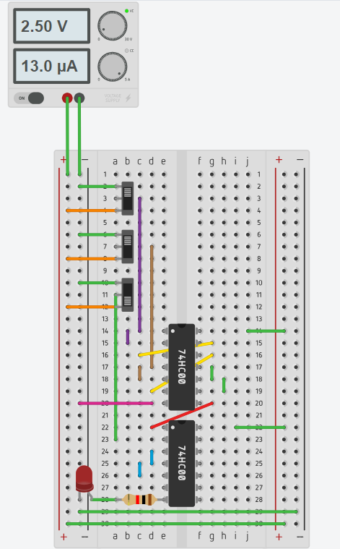

1. **What might be the reasons for not stating a sensor for detecting maximum water level of Underground storage**

Certainly, here are some reasons for not including a sensor to detect the maximum water level in the underground storage tank in the scenario:

1. **Sufficient Capacity**:

The underground storage tank has a maximum capacity of 3000 liters, significantly larger than the overhead tank's capacity of 1000 liters. The capacity of the underground tank is designed to provide ample water reserve for the overhead tank. Therefore, there's no need to constantly monitor the maximum level in the underground tank as it's unlikely to reach its limit while filling the overhead tank.

1. **Complexity and Cost**:

Adding a sensor to detect the maximum level in the underground storage tank would increase the complexity of the system and add extra costs. The cost of the sensor, wiring, and associated circuitry may not be justified when there is already a substantial margin between the tank capacities.

1. **Reliability**:

Introducing more components into the system, such as additional sensors, can potentially increase the chances of system failures or malfunctions. Keeping the system simple without a maximum level sensor in the underground tank reduces the risk of component failures and makes the system more reliable.

1. **Maintenance**:

Sensors require regular maintenance and calibration to ensure accurate readings. Omitting a sensor for detecting the maximum level simplifies maintenance, as one less component requires attention and upkeep.

1. **Energy Conservation**:

The omission of the sensor contributes to energy conservation. Sensors typically consume power continuously to monitor conditions. By not continuously monitoring the maximum level in the underground tank, the system conserves power and resources.

1. **Cost-Effectiveness**:

In many practical scenarios, the main goal is to ensure a steady supply of water to the overhead tank without exceeding its capacity. The existing conditions for controlling the pump (i.e., turning it on when the overhead tank is below a certain level and turning it off when the tank is full) are sufficient for achieving this goal.

In conclusion, for the given application, where the primary focus is to maintain the water level in the overhead tank within desired limits, including a sensor to detect the maximum water level in the underground storage tank might not be necessary. The existing conditions and system design are sufficient to ensure the proper functioning of the system and meet the water supply requirements.

Top of Form

END